How can Big Mountain resort increase their revenue?

The goal of this project is to find new business strategies that will balance the incomes vs operating costs of the resort, and eventually increase the revenue.

In attempt to find solutions for this goal we used a dataset with information about different ski resorts across the US. This data set includes tickets prices for the resorts, and a lot of other features, that some of them affect these prices.

After cleaning the data and a careful analyzes we found that the distribution for weekday and weekend prices in Montana (where Big Mountain resort is) seemed equal (Figure 1). Weekend prices have the least missing values of the two, so we used those values in our analyzes.

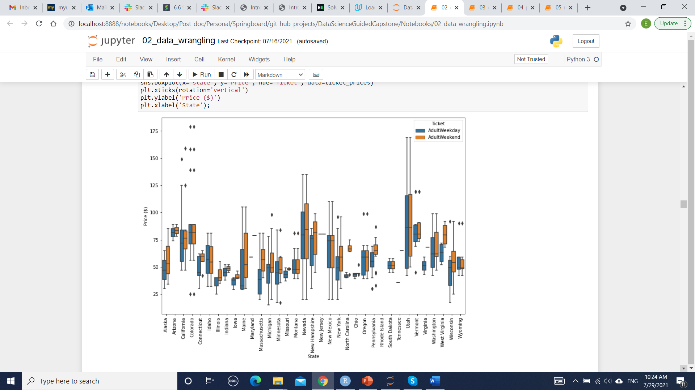

Figure 1: ticket prices by type and state.

The current ticket price at the Big Mountain resort is $81.00 for an adult, though the model predicts that this price should be higher than that - around $95.52.

To understand what are the factors that will most likely affect ticket prices we checked the correlation between the price and the different features (Figure 2).

This analyzes revealed several features that can be correlated with ticket prices:

* vertical_drop
* Snow Making_ac
* total_chairs
* fastQuads
* Runs
* LongestRun_mi
* trams
* SkiableTerrain_ac

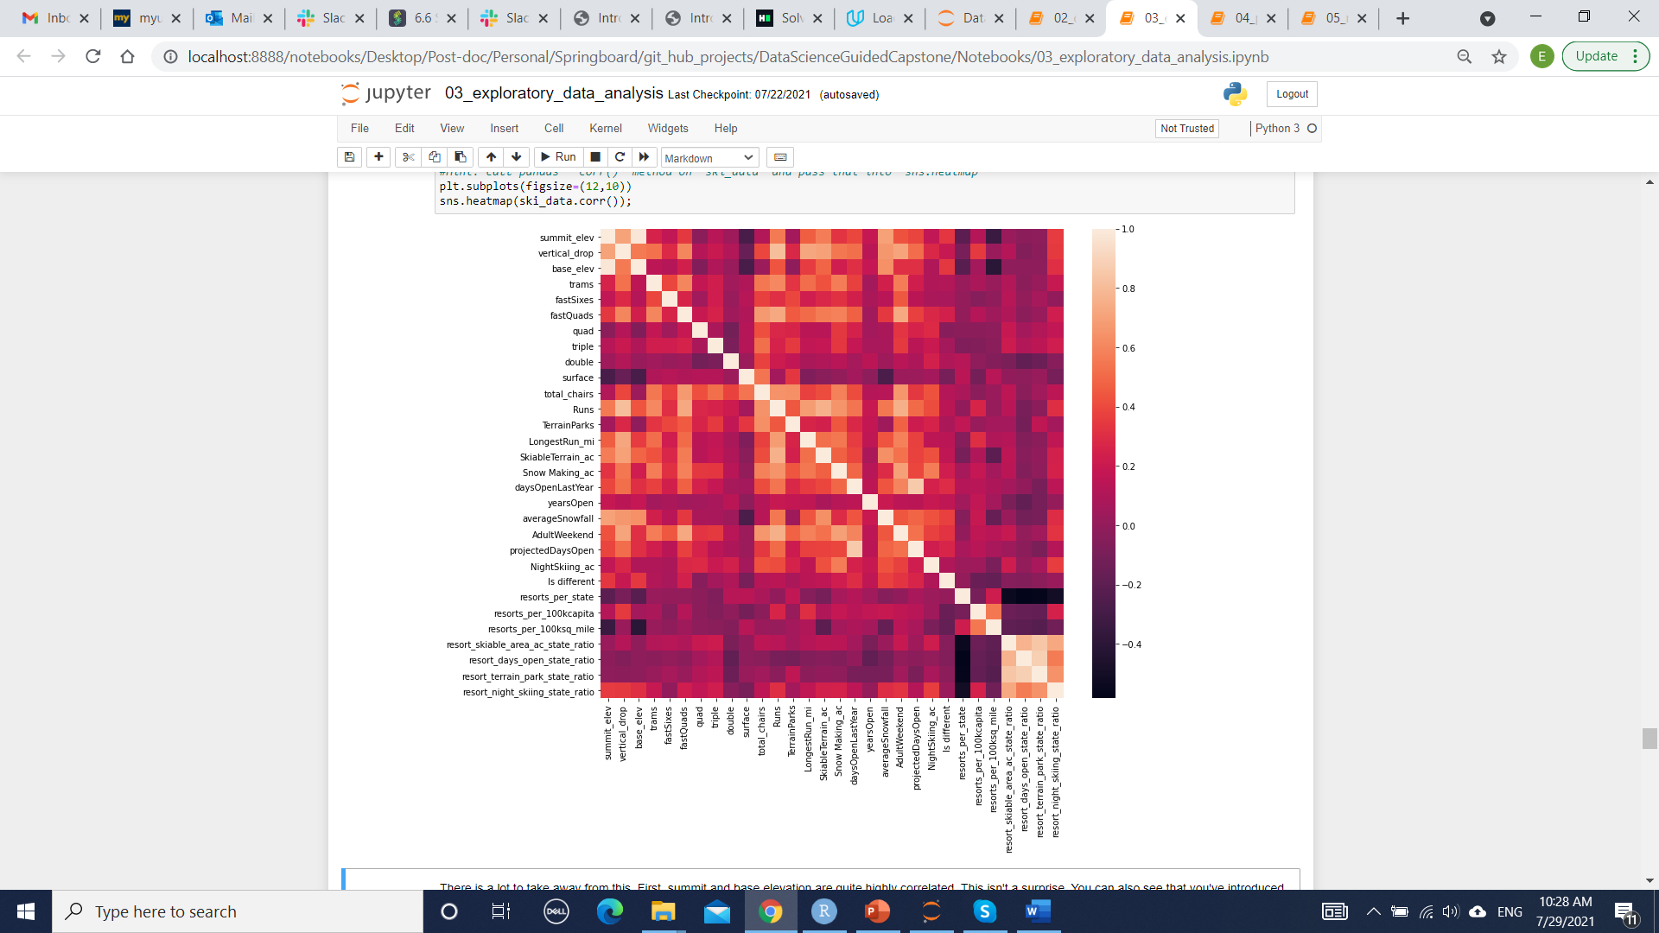

Figure 2: Correlations between different features in the data.

We build several machine learning models to assess how each of these features affect the price, and eventually we decided to use the random forest model (as it produced the low error rate and lower variability). This model highlighted the most important features to our analyzes (Figure 3)

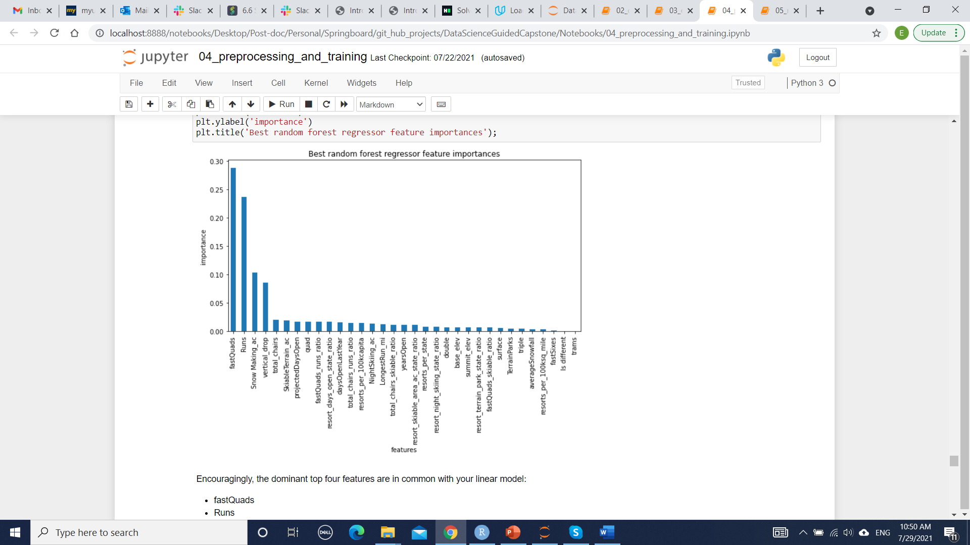

Figure 3: Best random forest regressor feature importance.

We then reviewed the following potential scenarios for either cutting costs or increasing revenue:

1. Permanently closing up to 10 of the least used runs. This doesn't impact any other resort statistics.
2. Increase the vertical drop by adding a run to a point 150 feet lower down but requiring the installation of an additional chair lift to bring skiers back up, without additional snow making coverage
3. Same as number 2, but adding 2 acres of snow making cover
4. Increase the longest run by 0.2 mile to boast 3.5 miles length, requiring an additional snow making coverage of 4 acres

We reviewed each of the above scenarios using our model, under the assumption that the expected number of visitors over the season is 350,000 and, on average, visitors ski for five days.

Based on our analyzes we can recommend two main options:

1. Closing 5 runs, as this will not affect ticket price, and will decrease the operating costs.
2. Increasing the vertical drop by 150 feet and installing an additional chair lift will cost the resort some initial and operating costs, but will enable to resort to increase the ticket price in 1.57$ and over the season will result in an increase of $2750000.

For future analyzes and to be able to perform a more accurate analyzes it would be great if we would have some more information, mainly the cost of adding and operating longer runs, bigger snow areas and additional vertical drops.